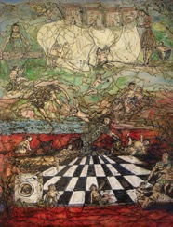  Imposing order on chaos, 2019  bitumen paint and oil on canvas  83x103x5cm | 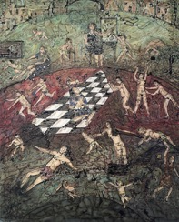  Confidence Tricks 2019  bitumen paint and oil on canvas  83x103x5cm
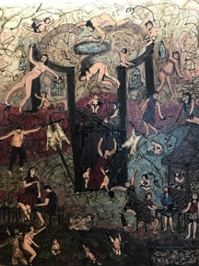  Encased in a new silence, 2019  bitumen paint and oil on canvas  80x100x5cm | 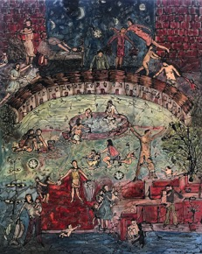  Sleepless Nights, Complicated Days,  2020, bitumen paint and oil on canvas  80x100x5cm
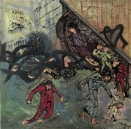  She wanted to swim through the broadest lives, 2020  bitumen paint and oil on canvas  50x50x5cm  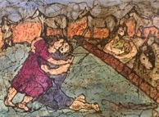  A much needed perspective on anxiety,  2020, bitumen paint and oil on canvas  70x50x5cm  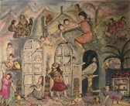  A reflection of the transparency of care around the world, 2020  watercolour and ink on paper  50x40cm  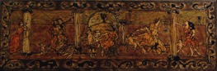  Architecture of the self, 2019  bitumen paint and oil on canvas  92x32x5cm | 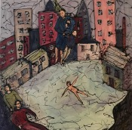  Above the rush of wind there is always tenderness, 2020  bitumen paint and oil on canvas  50x50x5cm  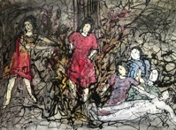  The adoration of self-sacrifice,  2020, bitumen paint and oil on canvas  70x50x5cm  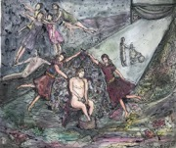  When the darkness takes you with her hand across you tell her your name, 2020  watercolour and ink on paper  50x40cm  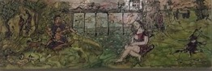  White rhino, black rhino, 2019  bitumen paint and oil on canvas  92x32x5cm
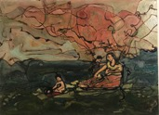  Caring for M-idyll England, 2018  bitumen paint and oil on canvas  35x30x3cm | 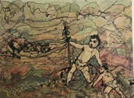  No rest for the wicked, 2018  bitumen paint and oil on canvas  35x30x3cm

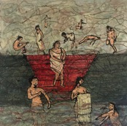  Pooling free time, 2020  bitumen paint and oil on canvas  50x50x5cm | 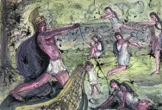  All the people we have to be to get through the day, 2020  watercolour and ink on paper.  42x30cm

