Object Relation

small sculptures of found objects and ceramic figures by Delpha Hudson
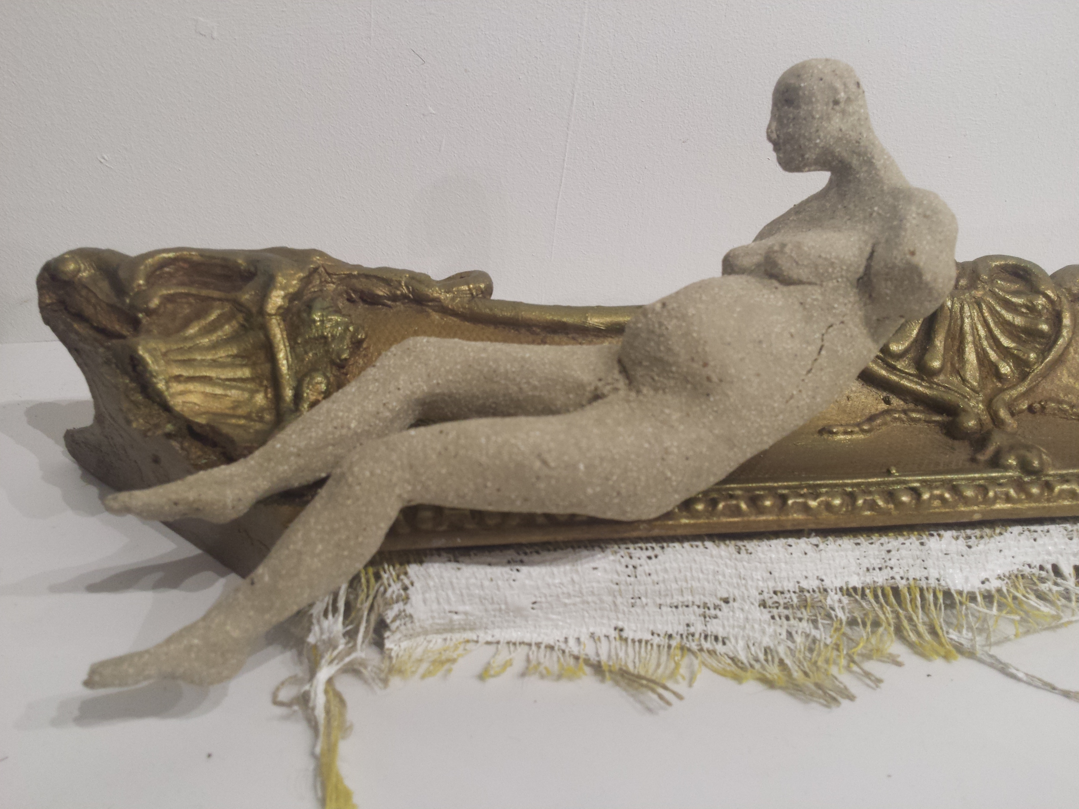
Odalisque, 45x13x16cm, broken antique frame and pregnant ceramic figure
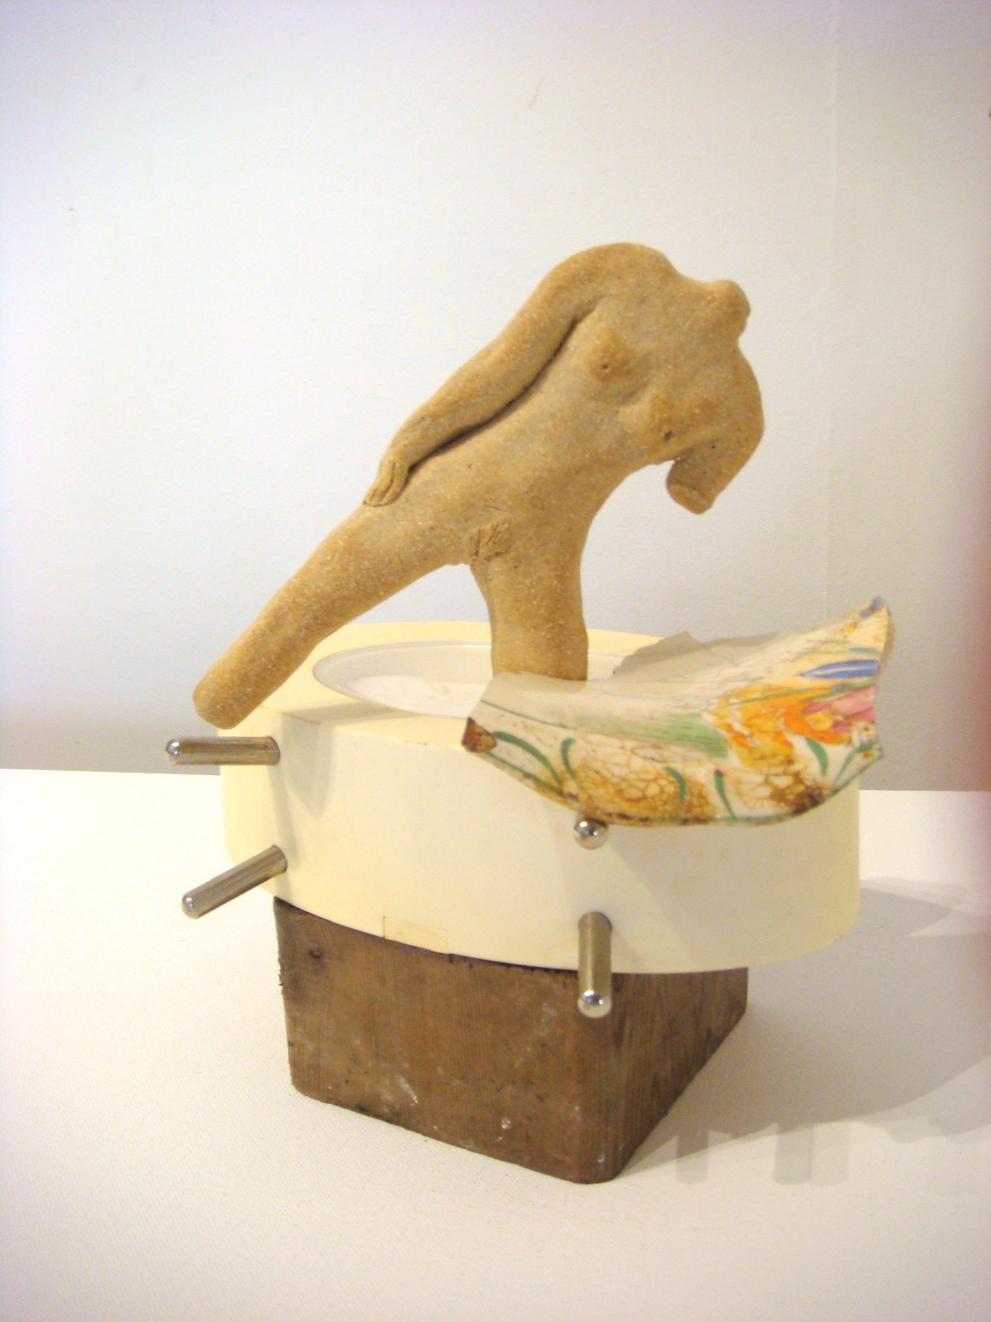
Upon a Time (Once), 20x20x10cm, driftwood, ceramic shard and figure
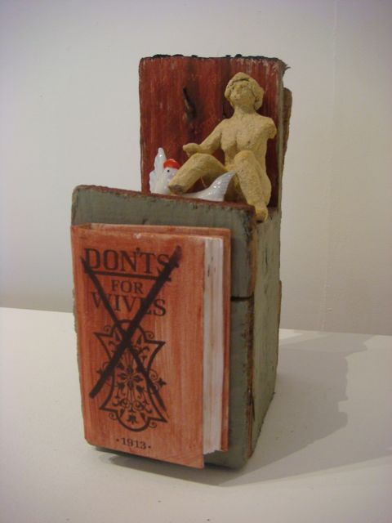 Don’t……driftwood, 23x22x9cm, ceramic chickens, book ‘don’ts for wives’, (1913) and ceramic figure
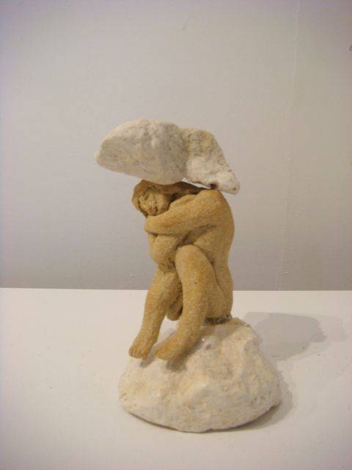
Fallen-Caryatid, 16x9x9cm, ceramic figure, found Norfolk chalk,
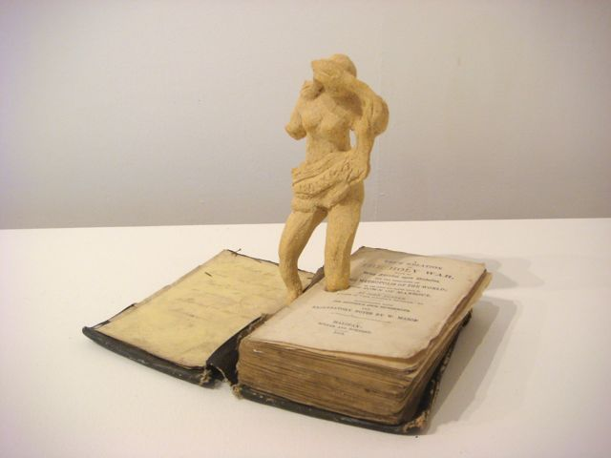
Marginalia, 17x20x13cm, Bunyan’s book ‘A true relation of the Holy War’ and ceramic figure
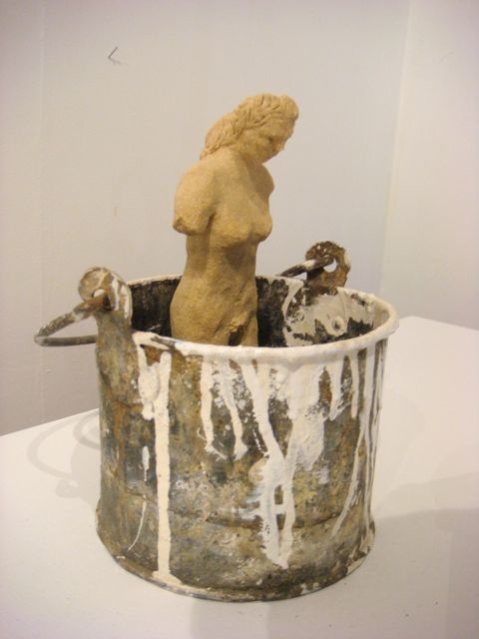
AUT VIAM INVENIAM AUT FACIAM (I will find a way or make one), 23x17x17cm, found paint tin with ceramic figure
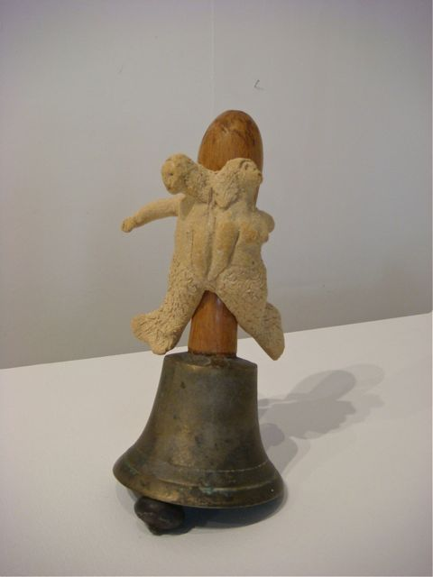
Dos-à-dos (back to back), 20x9x9cm, bell with conjoined mermaid and merman attached to handle
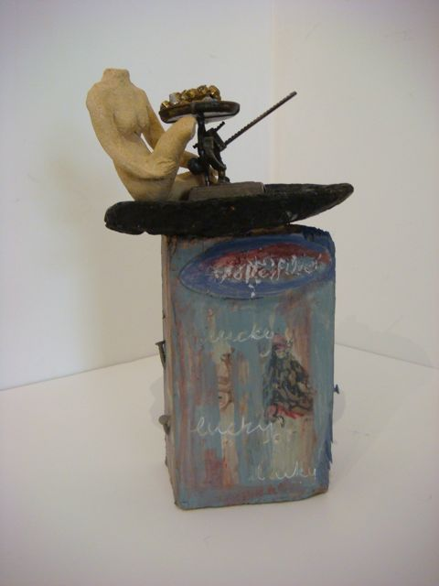
Rich as Croesus, 26x18x18cmdriftwood, tiny model scales, found tyre and posters (La tarot), with ceramic figure,
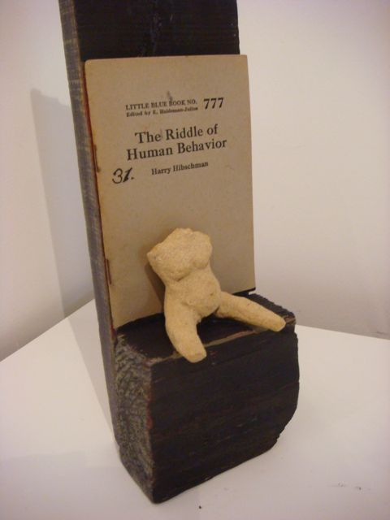
The riddle of human behaviour, 40x10x6cm, driftwood, book and figure
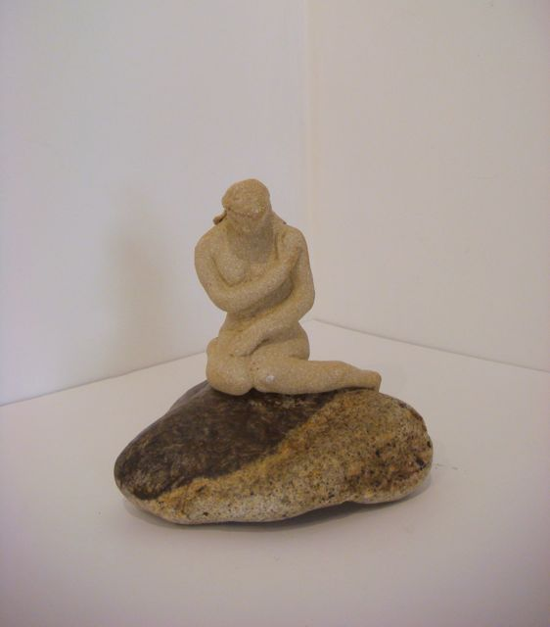

Antediluvian, 13x12x13cm, granite stone and ceramic figure
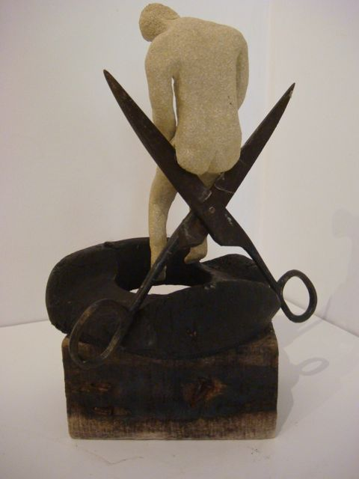
The first cut is the deepest, 29x15x17cm, driftwood, scissors, found plastic and ceramic figure
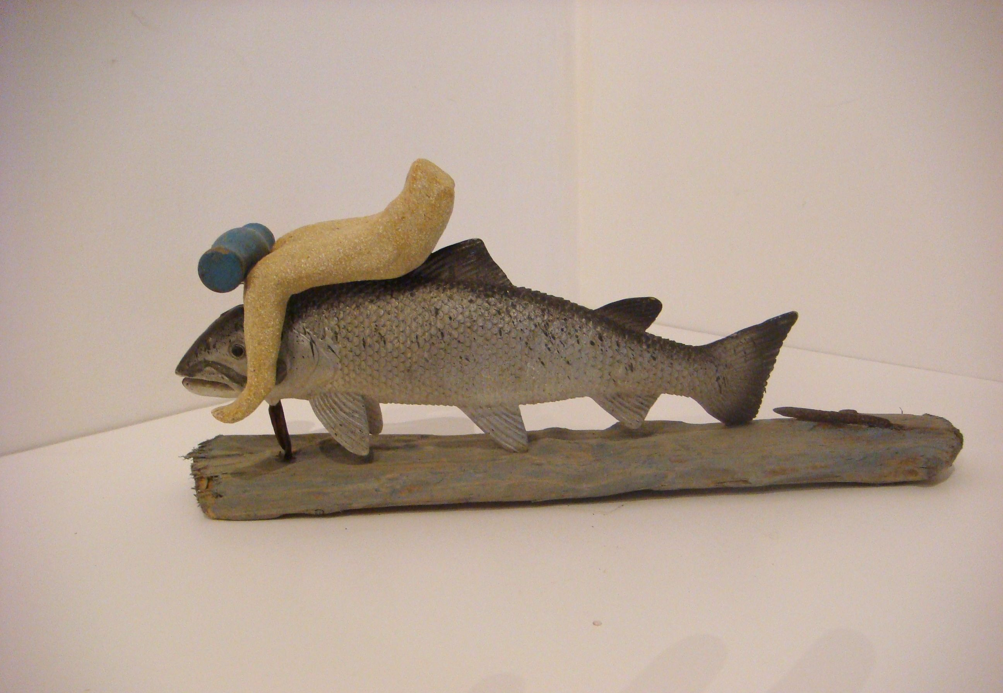
Life is a surreal ride, 30x13x6cm, driftwood, plastic fish, found screwdriver and ceramic figure
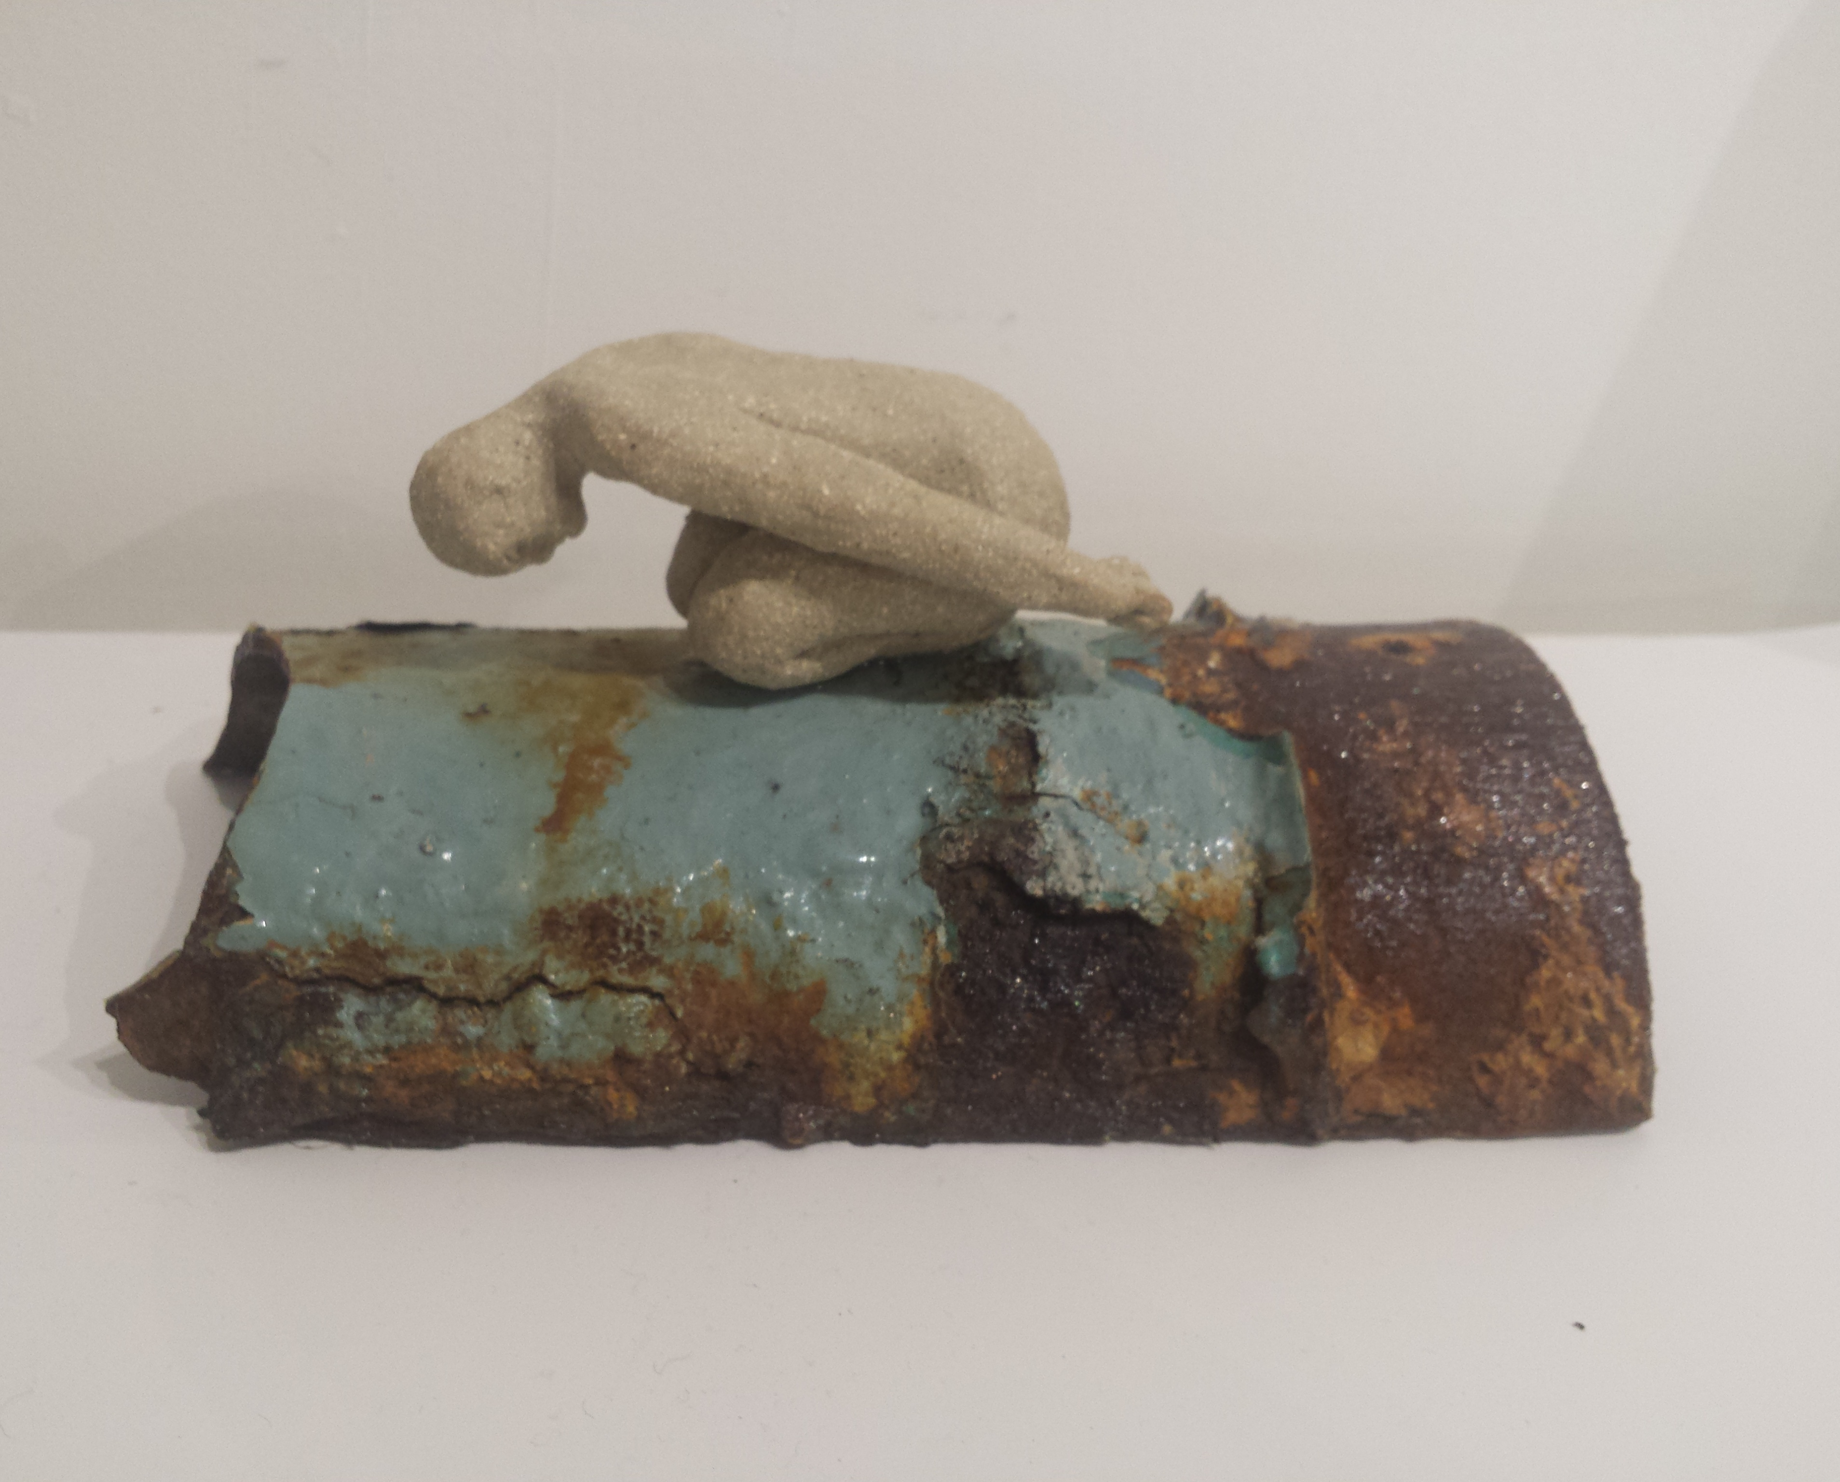

Enough, 24x10x10cm, ceramic figure on rusted drainpipe
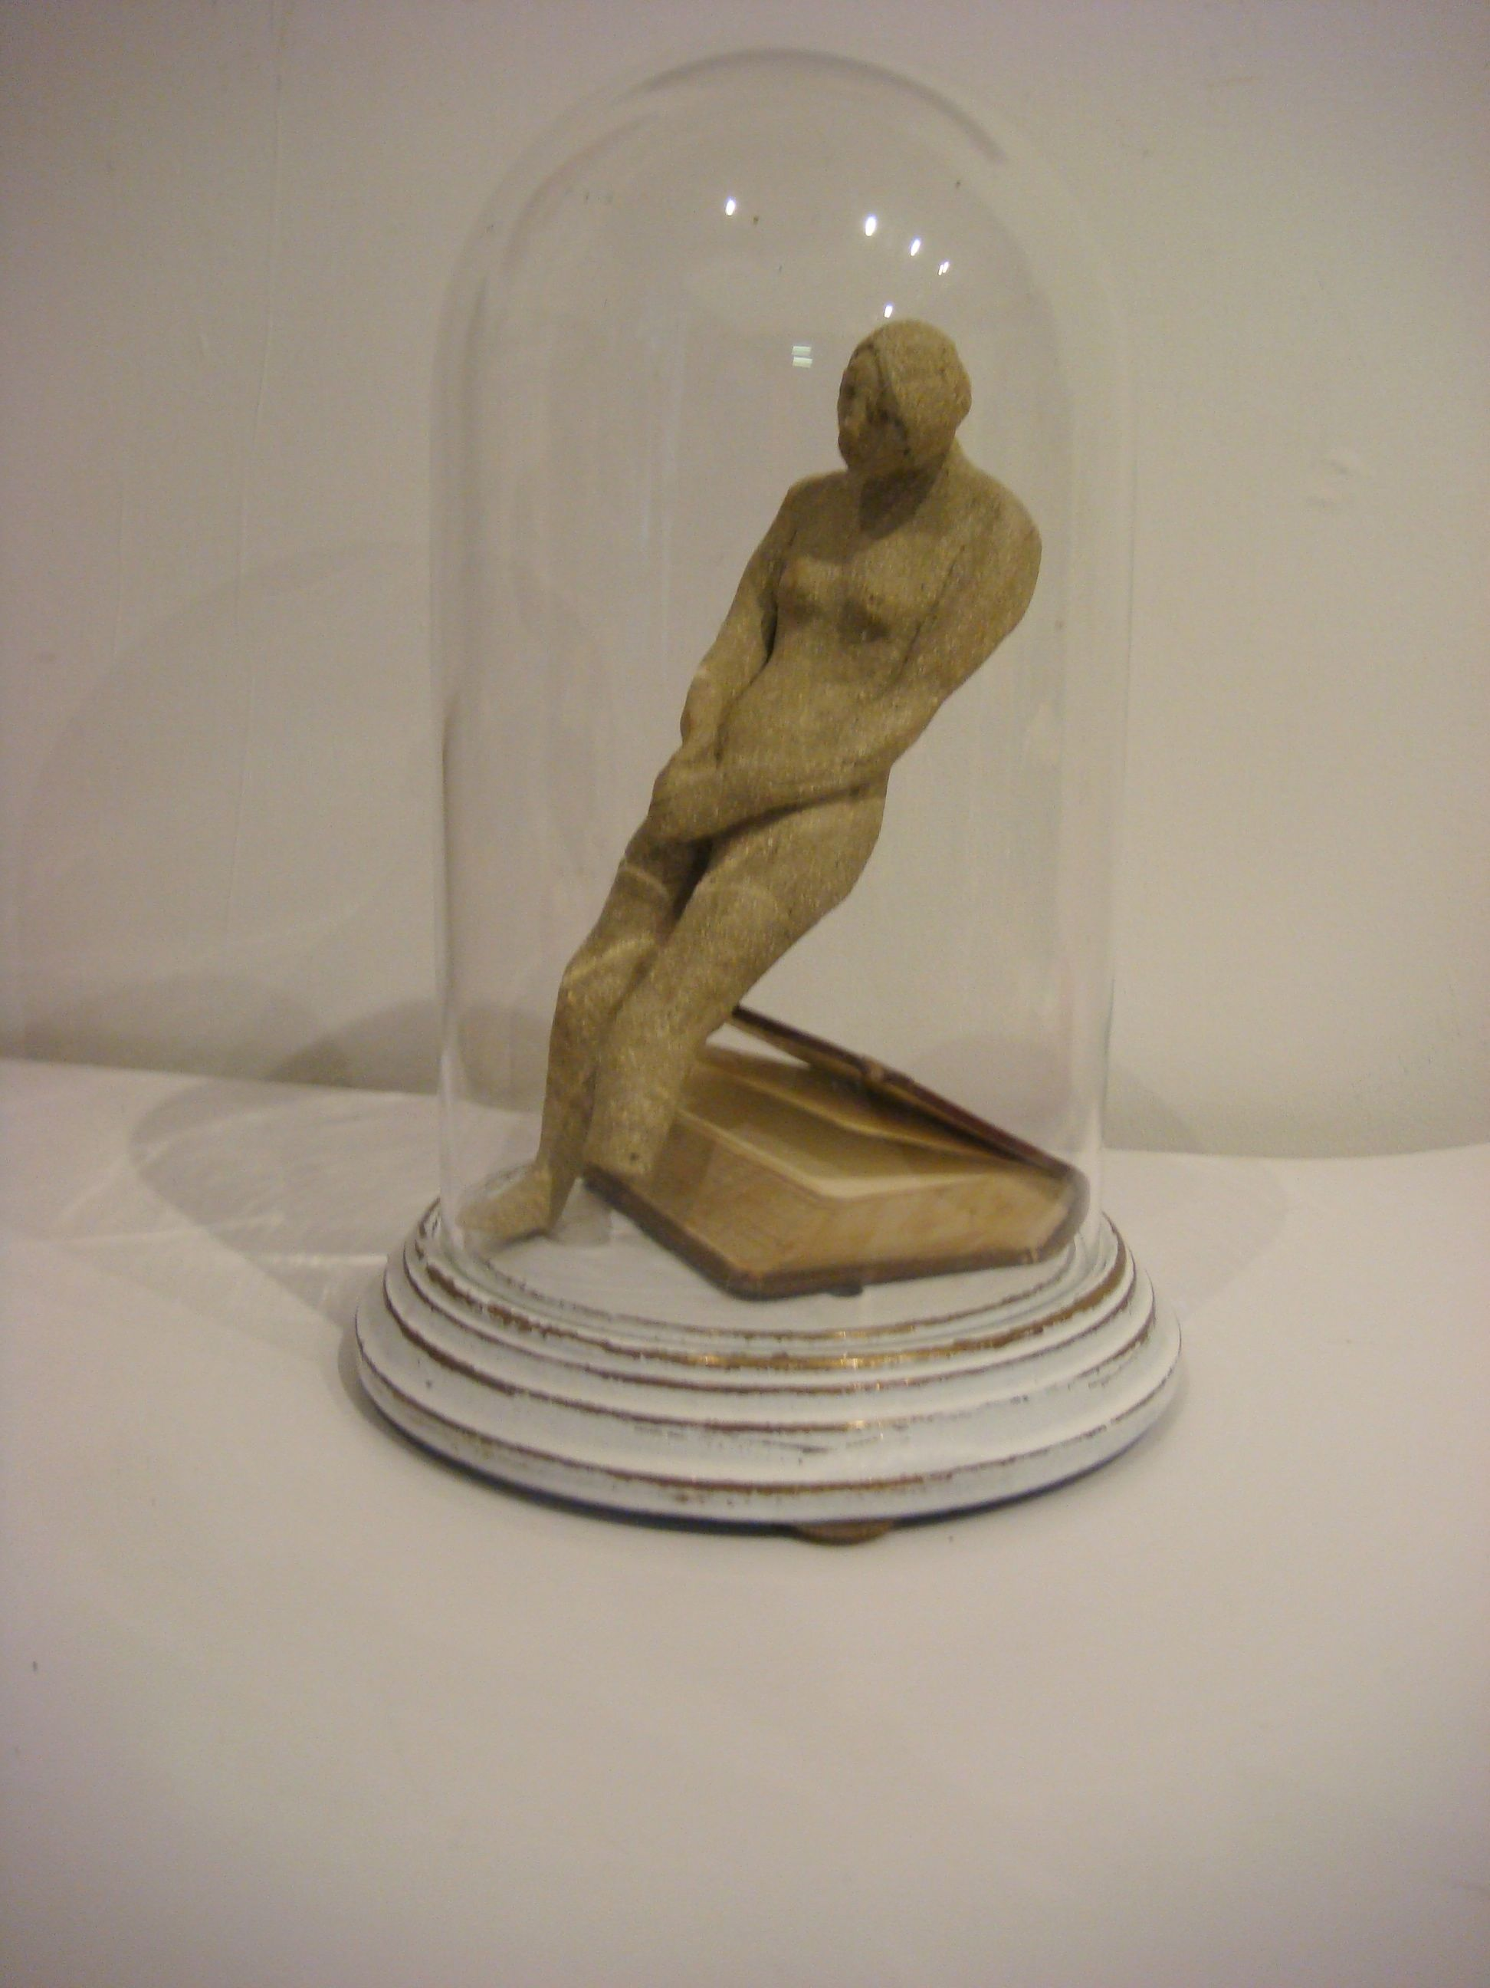
Plath, 24x15x15cm, ceramic figure and small sized book in a bell jar

Many more figures available

